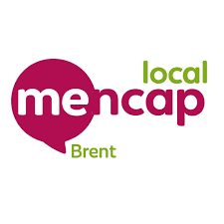
DRaP NEWS
Disability, rights and politics

Breaking a concrete ceiling – WOW!

We are the DRaP group at Brent Mencap  We meet every Wednesday to talk about issues that affect people with a learning disability in Brent. | 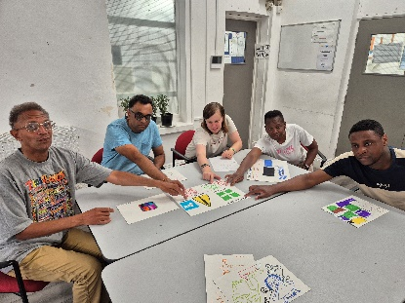
We want to tell you what we have been doing.  And we want to hear from you. | 
Have you heard the amazing news?  Nnenu Kalu has won the Turner Prize! | 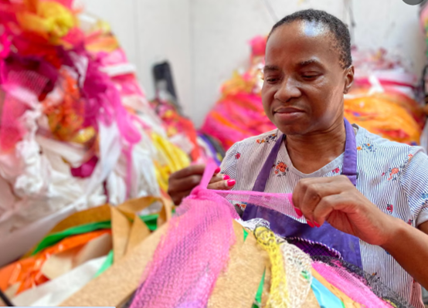
Nnenu has been supported by the wonderful ActionSpace.  They support artists who happen to have a learning disability.  https://actionspace.org/ | 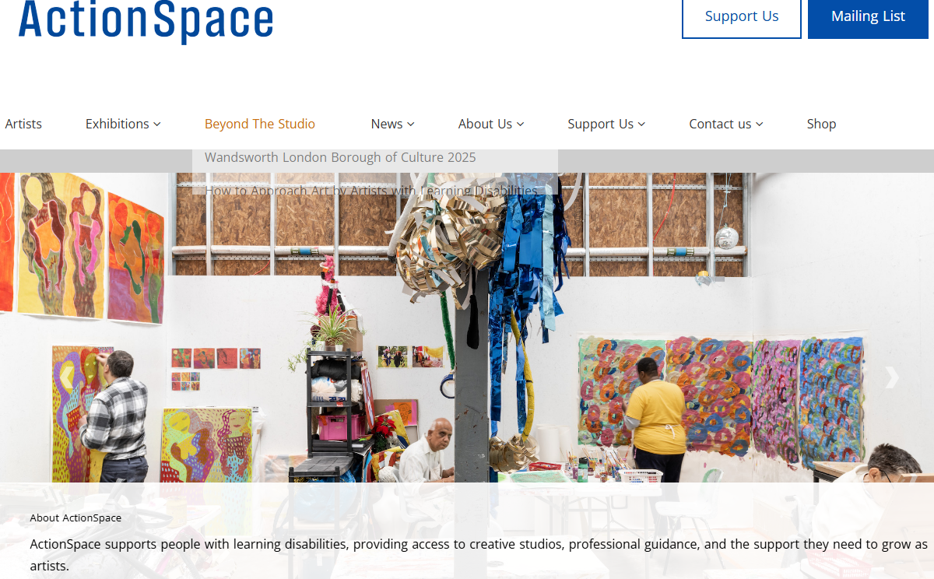
Nnenu has shown the art world that an artist is an artist.  A learning disability makes no difference.  We know some of us are excellent – we just need to be respected and included. | 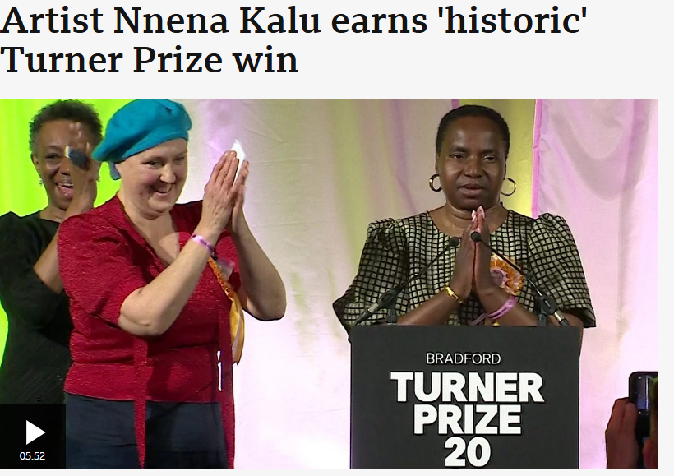  https://www.bbc.co.uk/news/articles/c5yqvz9wljqo
We are proud to be a partner of ActionSpace who have given us lots of wonderful opportunities. | 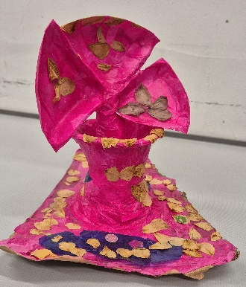  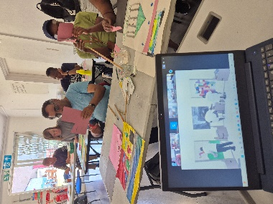
We would like to hear about your experiences of living with a learning disability in Brent  Please contact us on  advocacy@brentmencap.org.uk | 

