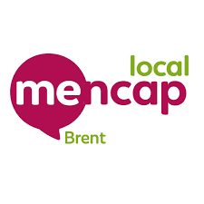
DRaP NEWS
Disability, rights and politics

Co-production

We are the DRaP group at Brent Mencap  We meet every Wednesday to talk about issues that affect people with a learning disability in Brent. | 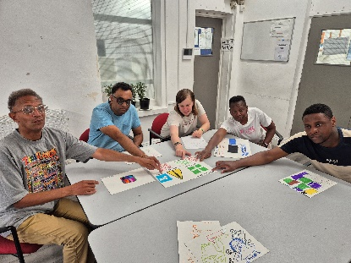
We want to tell you what we have been doing.  And we want to hear from you. | 
We meet with Daniella on Mondays at the Civic Centre. She works with the Brent Council Co-production team. | 
As a group we are trying to make the information on Brent Council documents Easy Read. | 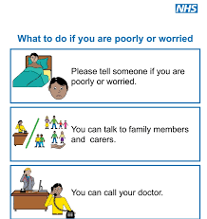
For Example, we looked at a leaflet about hospitals.  We said what we understand and what would make it better. | 
Some people need Easy Read. | 
Some people need pictures. | 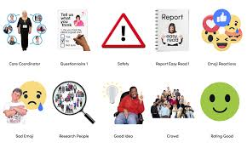
Some people need sign language. | 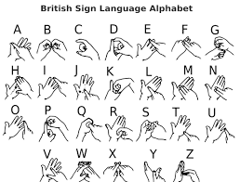
Everybody needs the same information, but in different ways so they understand. | 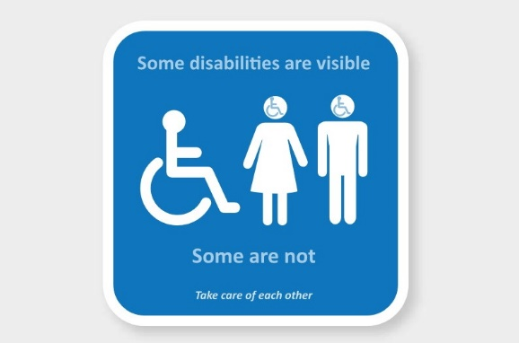
We are going to carrying on with Daniella. | 
We would like to hear about your experiences.  Please contact us on  advocacy@brentmencap.org.uk | 

