DRaP NEWS
Disability, Rights and Politics

January 20206 - Employment

 | We are the DRaP group at Brent Mencap.  We meet every Wednesday to talk about issues that affect people with a learning disability in Brent.
 | We want to tell you about issues with employment for adults with a learning disability.
 | Many of us want to work to use our skills and make friends.
 | We want to get a job and make money like everyone else and be able to pay bills.
 | Only 1 in 20 people with a learning disability have paid work.  This is worse than any group of people we know.
 | It is difficult for some of us to understand job applications and do interviews.  Because they are not in Easy Read.  This makes us feel upset that we have not been given chance.
 | For many years in Brent there has been support for adults with physical disabilities or mental health problems.  But not for adults with a learning disability.
 | We spoke to the council many times over the last 3 years.  Nothing has happened.  Council officers listen to us, but do not take action.
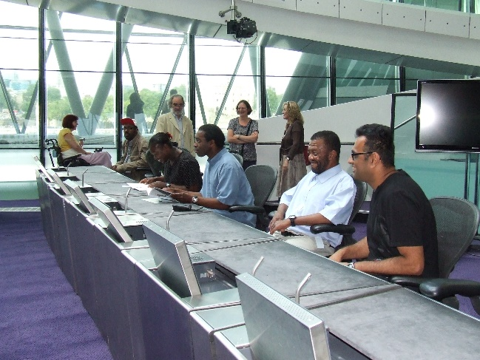 | Brent Council and the London Assembly have given us lists of organisations who can help.  But none of the organisations we spoke to have helped someone with a learning disability get a job.  We tried to contact Brent Works – but they have not got back to us yet.
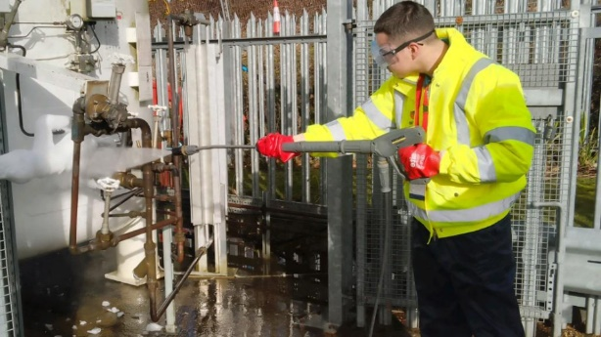 | It seems that younger people are getting more opportunities.  Like internships.  This is good news.  We would like to know if this has got anyone a job.
 | Finally, we got 6 months’ support from BEAM.  But that stopped in March 2025.  So, we had nothing again.
 | There might be some hope!  Connect to Work have said they can help us find a job.  https://shawtrust.org.uk/commissioning-connect-to-work/
 | We have listened to many people in the past, and nothing has come of it.  So, we will see if we do get jobs…  We will let you know in 6 months’ time.
 | We would like to hear about the experiences of people with learning disabilities getting work.  Please contact us on  advocacy@brentmencap.org.uk

