
DRaP NEWS
Disability, rights and politics

Transport

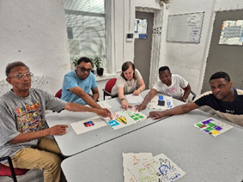 | We are the DRaP group at Brent Mencap  We meet every Wednesday to talk about issues that affect people with a learning disability in Brent.
 | We want to tell you about issues with transport for London and we want to hear from you.
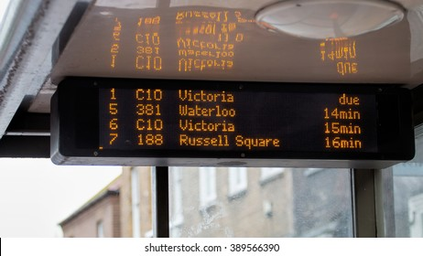 | The mayor of London, Sadiq Khan, wants to get rid of digital bus screens at bus stops around London.
   | Some people don’t have smartphones to check when a bus is coming.
 | If there are no more digital bus screens with times, it will make it harder for us and people with learning disabilities.
 | We would like to hear about your experiences.  Please contact us on  advocacy@brentmencap.org.uk

