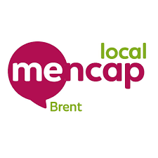
DRaP NEWS
Disability, rights and politics
April 2026 - Brent Hubs

We are the DRaP group at Brent Mencap  We meet every Wednesday to talk about issues that affect people with a learning disability in Brent. | 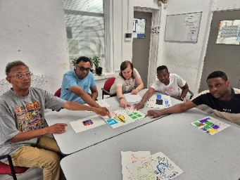
We want to tell you what we have been doing.  And we want to hear from you. | 
We visited the Brent Hub Team at Harlesden Library.  We told them how they can help people with a learning disability. | 
They listened carefully and showed a lot of interest.  Normally people seem to listen to us, but they go away and do nothing.  But after our meeting they came and spoke to us. | 
They do more than we realised –  Food aid  Computers – Doing things online  Digital courses  Finding work  Benefits  Money advice  Housing  Freedom Passes  Form filling  And more… | 
So, if you have a learning disability go to the Hubs
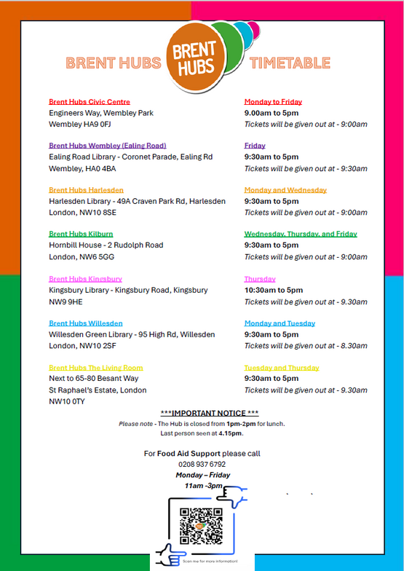
We would like to hear about your experiences of living with a learning disability in Brent  Please contact us on  advocacy@brentmencap.org.uk | 

